**Business Requirements Specifications (SRS)**

**ERP Solution for Lakhsma**

REFERENCE: GW/ERP/BRS

**Version: 1.0**

**Date of Release: September 14, 2015**



**Genweb2 Limited**

TK Bhaban (11th Floor),

13 Kazi Nazrul Islam Avenue,

Kawran Bazar, Dhaka 1215, Bangladesh

web: [http://www.genweb2.com](http://www.genweb2.com/)

**Contents**

Document Release History 4

1.0 Introduction 5

1.1 Purpose of BRS 5

2.0 Merchandising 6

2.1 Overview 6

2.2 Merchandising Process Flow 6

2.3 Merchandising use case diagrams and description 7

2.3.1 Quotation Process: 7

2.3.2 Sample Requisition and submission Process 9

2.3.3 Buyer Order Confirmation 11

2.3.4 BOM (Bill of Material) Generation Process 13

2.4 Merchandising User Interface mock-up 15

2.4.1 Style 15

3.0 Procurement 20

3.1 Overview 20

3.2 Procurement Process Flow 20

3.3 Procurement use case diagram and description 21

3.3.1 Purchase Requisition 21

3.3.2 Supplier Purchase Order: 23

3.4 Procurement User interface mock-up 25

3.4.1 Supplier Purchase Requisition 25

3.4.2 Supplier purchase order 26

4.0 Inventory 27

4.1 Overview 27

4.2 Inventory process flow 27

4.3 Inventory Use case diagram and description 28

4.3.1 Inventory Receive 28

4.3.2 Inventory QC 30

4.3.3 Inventory Transfer 32

4.3.4 Inventory Allocation and De-allocation 34

4.3.5 Inventory issue 36

4.4 Inventory user interface mock-up 38

4.4.1 Inventory receive 38

4.4.2 Inventory QC 38

4.4.3 Inventory transfer 39

4.4.4 Inventory Allocation & De-allocation 39

4.4.5 Inventory issue 40

Document Release History

| Sl. No. | Version Number | Release Date | Prepared By | Reviewed By | Approved By | Reasons for New Release |
| --- | --- | --- | --- | --- | --- | --- |
| 1 | 1.0 | 14th Sep, 2015 | Nazifa Chowdhury |  | N/A |  |

# Introduction

## Purpose of BRS

The purposes of this BRS are to clearly identify the customer’s business requirements and provide a detailed document. The customer will review the document and approve/make change if required. It will also help the review team to be able to validate whether the business requirements have been fulfilled or not.

The BRS will also help the Analyst and Designer to understand and track the requirements for the proposed system. It will also identify a set of requirements for the development of the project. The BRS helps to describe the behavior of the system to be developed.

**Proposed Modules:**

In this document we are considering three modules of three major departments of Lakhsma Sweater. The modules are:

1. Merchandising
2. Procurement
3. Inventory

# Merchandising

## Overview

Merchandising is the heart of the Garments industries. Though the overall process of merchandising involves any sort of direct and indirect activities which is associated with any certain order given by buyer from inquiry to shipment but core activities are Quotation management, Sampling management, Consumption and Bill of Materials generation.

## Merchandising Process Flow

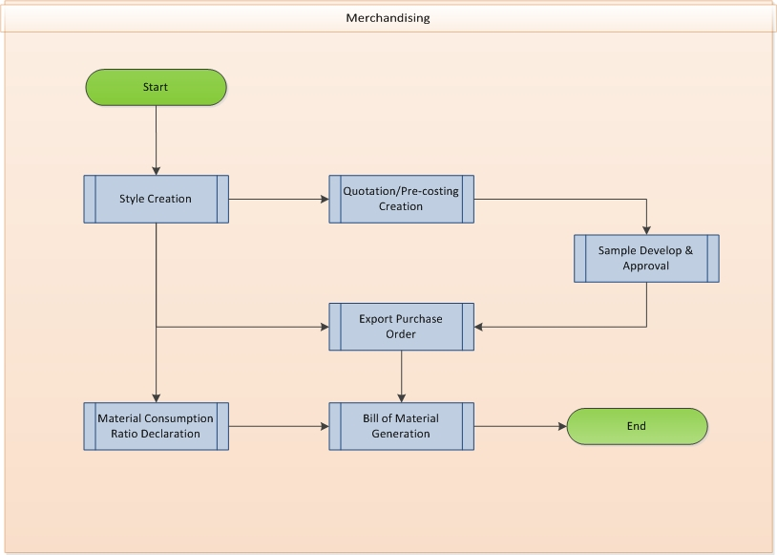

Fig: Merchandising Process Flow

## Merchandising use case diagrams and description

### Quotation Process:

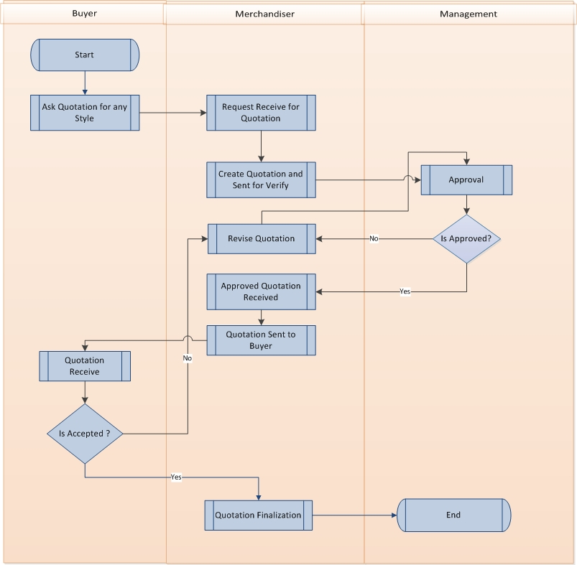

Fig: Pre-Quotation

|  |  |  |
| --- | --- | --- |
| Use Case ID: UCD/Mer/001 | | |
| Use Case Name**: Quotation Process** | | |
| Created By: **GenWeb2 Ltd.** | | Date Created: **10 September 2015** |
| Actors: | * Merchandiser, Buyer, Management | |
| Trigger: | * When buyer wants to know the costing of any certain style | |
| Business Rule | * Pre cost calculation and finalization | |
| Description: | 1. Buyer ask the quotation for any specific Style 2. Respective Merchandiser goes for every single elements to calculate the costing along with CM and Profit margin 3. Prepare quotation 4. Merchandiser takes approval from management on the prepared quotation 5. If the quotation is approved then merchandiser submit the quotation to Buyer else he revises the quotation and resubmits for approval 6. Negotiation may take place with buyer 7. Based on negotiation between merchandiser and buyer, merchandiser can submit quotation multiple times. 8. In one stage of negotiation both party finalize the quotation | |
| Frequency of Use | * High | |
| Preconditions | * Defining Style * Tech pack details | |
| Post conditions | * Order confirmation, booking or cancellation by the buyer | |
| Assumption | * Already in practice | |
| Goal | * Enter new quotation in system to make it easy and integrated to the entire system, where it can be followed by the upcoming steps and eventually it can show a comparison report of the pre costing and the actual costing | |
| Normal Flow | * Merchandiser creates the quotation, pre costing and does the negotiation | |
| Alternate Flow | * N/A | |
| Exception | * N/A | |
| Cross Reference | * N/A | |

### Sample Requisition and submission Process

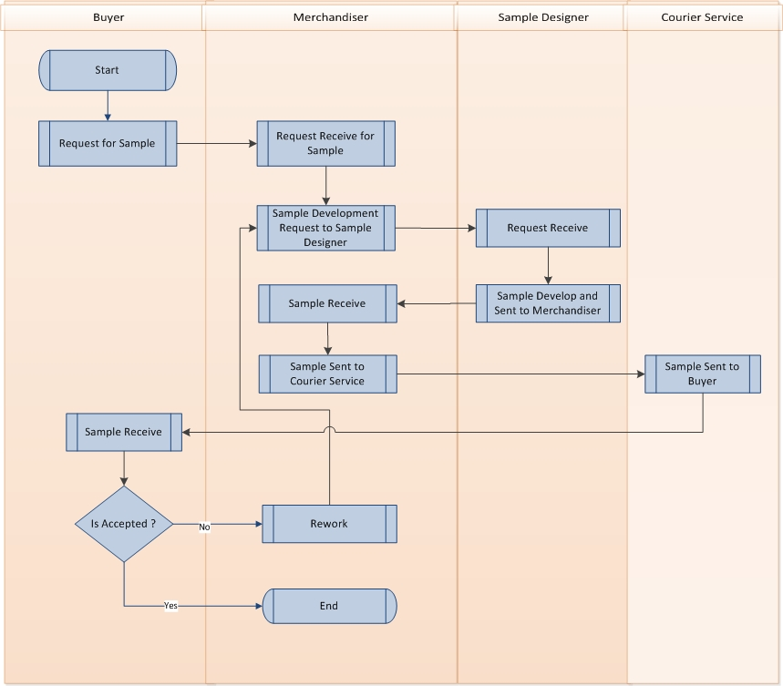

Fig: Sample Requisition and submission Process

|  |  |  |
| --- | --- | --- |
| Use Case ID: UCD/Mer/002 | | |
| Use Case Name**: Sample Requisition & Submission Process** | | |
| Created By: **GenWeb2 Ltd.** | | Date Created: **10 September 2015** |
| Actors: | * Buyer, Merchandiser, Designer(Sample Manager) | |
| Trigger: | * When buyer wants to have any type of Sample from the Manufacturer. Even though it can be in pre-sales stage. | |
| Business Rule | * Buyer give the sample requisition to the respective Merchandiser and Merchandiser develop the sample through sample department as per asking sample type | |
| Description: | 1. Buyer request for Sample 2. Merchandiser sends the sample requirement to sample team 3. Sample team develops the sample requested. 4. Merchandiser send the sample to the buyer 5. If buyer does not approve the sample then merchandiser re-develops the sample with the help of sample team and sends again. | |
| Frequency of Use | * High | |
| Preconditions | * Defining Style * Tech pack details | |
| Post conditions | * N/A | |
| Assumption | * Already in practice | |
| Goal | * Enter Sample Requisition in System to keep the record in system where it can minimize the Sample Requisition and Submission process with actual data. Eventually this information can help the organization to analysis anything regarding sampling process. | |
| Normal Flow | * Merchandiser receive sample request from the Buyer * Merchandiser forward the instruction of sample development to the sample development team | |
| Alternate Flow | * N/A | |
| Exception | * N/A | |
| Cross Reference | * N/A | |

### Buyer Order Confirmation

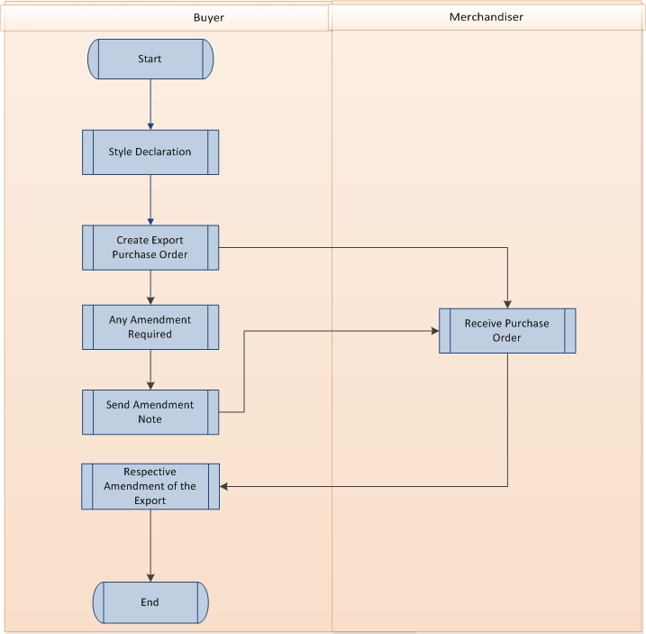

Fig: Buyer Order

|  |  |  |
| --- | --- | --- |
| Use Case ID: UCD/Mer/004 | | |
| Use Case Name**: Buyer Order Confirmation Process** | | |
| Created By: **GenWeb2 Ltd.** | | Date Created: **10 September 2015** |
| Actors: | * Buyer, Merchandiser | |
| Trigger: | * When Any Buyer confirms any Order (Give the Purchase order). | |
| Business Rule | * Buyer confirms any order by giving Purchase order. It contains all the color size wise order quantity and rate | |
| Description: | 1. Buyer gives the Export Purchase Order after quotation finalization. 2. Export Order contains details Color and size wise order quantity, Unit of measurement, rate, Currency, Shipment Date, Shipment Destinations, Shipping Mode, HS Code, tolerance, Delivery Terms etc. 3. If there is any amendment in Export Purchase Order then concern merchandiser receive that amendment note from buyer and address those amendment in Export Purchase Order. | |
| Frequency of Use | * High | |
| Preconditions | * Style Information * Pre Costing/Quotation finalization | |
| Post conditions | * Production Preparation & Execution. (Bill of Materials generation, Sourcing the raw materials, Production Planning | |
| Assumption | * Already in practice | |
| Goal | * All the production preparation and execution actions happen to execute the Purchase Order given by Buyer, so keep a record of the Export PO creates the relation what will be used as reference in every steps (BOM, Sourcing, Planning, Production & Shipment) to ensure the smooth tracking and productivity. | |
| Normal Flow | * Buyer Confirm the Order/Gives purchase order after successful sampling process and finalization of Quotation | |
| Alternate Flow | * Buyer can confirm the order/gives purchase order as a reorder of any earlier style or reference. | |
| Exception | * Buyer can give the order as a whole. Color size and destination wise breakdown may be confirmed later on. * Buyer can give a verbal confirmation. Actual Export PO may be given just before starting the production | |
| Cross Reference | * N/A | |

### BOM (Bill of Material) Generation Process

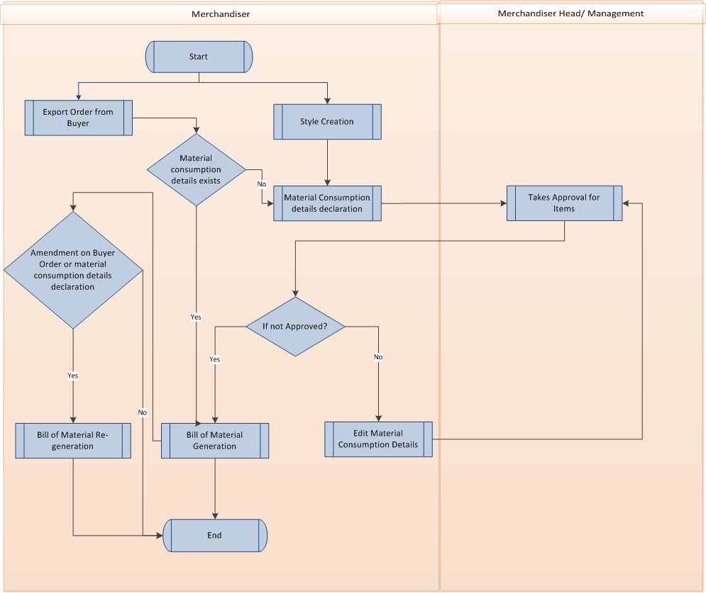

Fig: BOM (Bill of Material)

|  |  |  |
| --- | --- | --- |
| Use Case ID: UCD/Mer/005 | | |
| Use Case Name**: Bill of Material generation Process** | | |
| Created By: **GenWeb2 Ltd.** | | Date Created: **10 September 2015** |
| Actors: | * Merchandiser | |
| Trigger: | * When Buyer confirm the order quantity in details (Color & Size wise) and actual raw material consumption and been defined. | |
| Business Rule | * Generating all the raw material requirements details along with preferred and buyer nominated supplier details | |
| Description: | 1. Merchandiser gets export order from buyer 2. Respective Merchandiser generates the raw materials consumption of an ideal Finished Goods quantity (style). 3. Merchandiser will take consumption approval from management. 4. Considering the Export PO and Consumption logic, Total Raw material and quantity get generated. 5. Total raw material quantity generates by considering the shipment tolerance and wastage percentage. 6. If Amendment on buyer order takes place after BOM generation then BOM will be regenerated. | |
| Frequency of Use | * High | |
| Preconditions | * Export PO/Buyer Order details * Raw material Consumption logic | |
| Post conditions | * Sourcing of raw materials | |
| Assumption | * Already in practice | |
| Goal | * To generate the Bill of Material in a very easy and effective way * Ensuring the quantity of raw materials to in-house where there will be no shortage while the order will be in execution level. Also it will ensure that there will be very minimum number of leftover after production execution | |
| Normal Flow | * Merchandiser Receive the confirm Order (with quantity), Identify the raw materials consumption logic. Based on Export order and Consumptions Logic, BOM of materials get generated by multiplication. | |
| Alternate Flow |  | |
| Exception | * Buyer may not confirm the order in color size level. In that case Merchandiser generate the BOM as per assumed quanty, where it needs to regenerate while get the actual details order quantity. | |
| Cross Reference | * N/A | |

## Merchandising User Interface mock-up

### Style

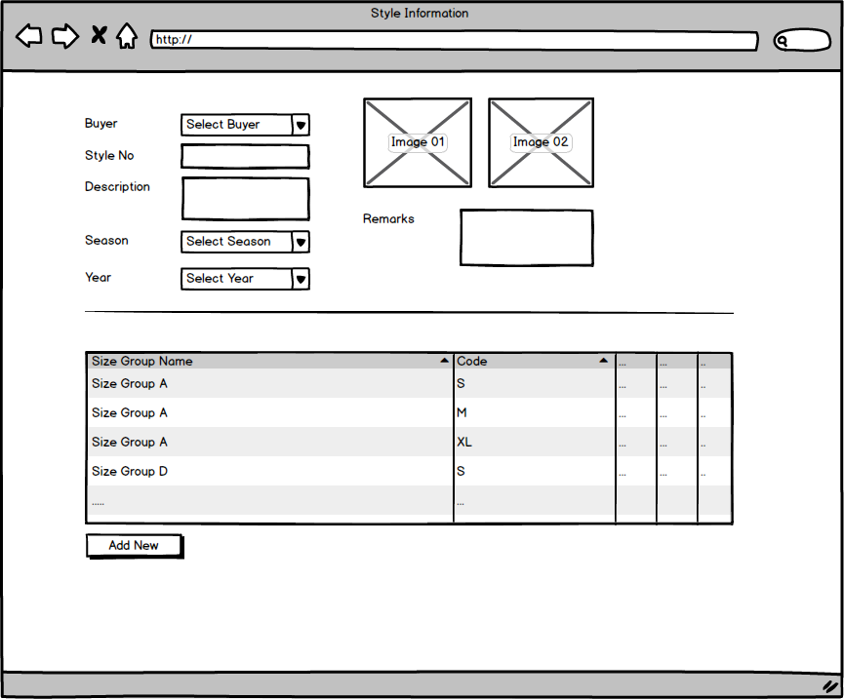

Fig: Style

* + 1. **Sample requisition and submission**

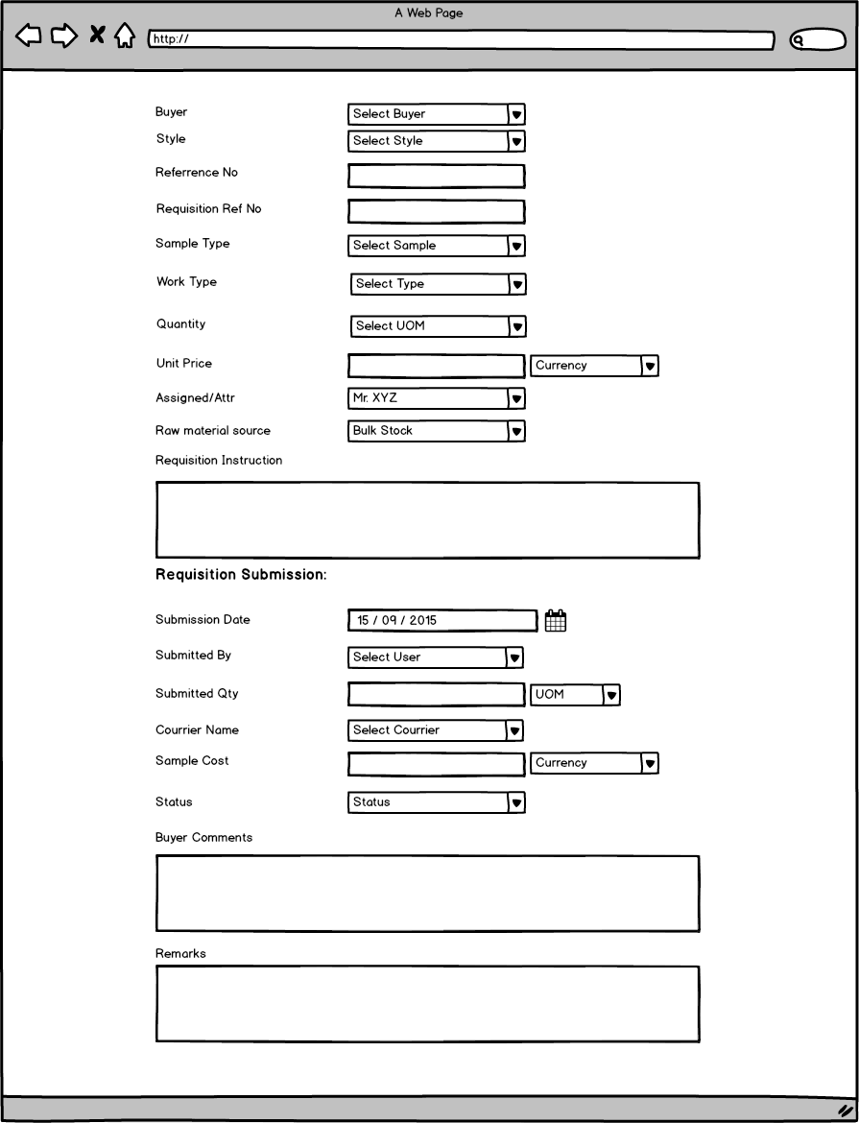

Fig: Sample requisition and submission

* + 1. **Pre-costing mock-up**

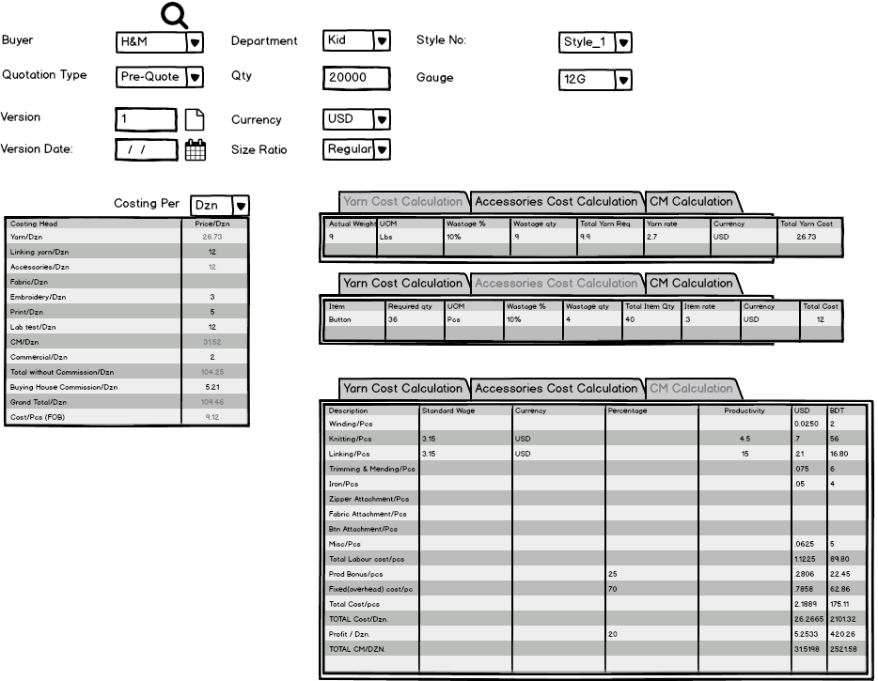

Fig: Pre-costing mock-up

* + 1. **Buyer work order**

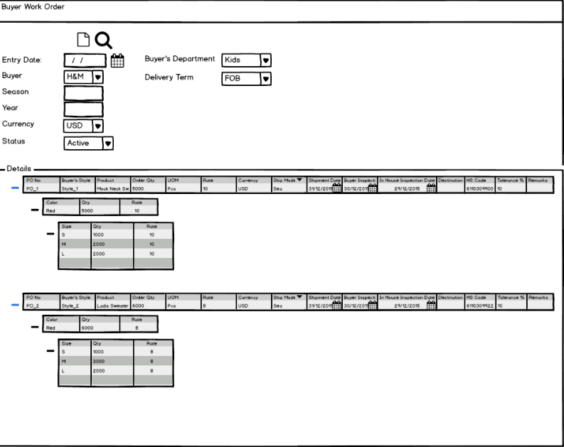

Fig: Buyer work order

* + 1. **Materials Consumption**

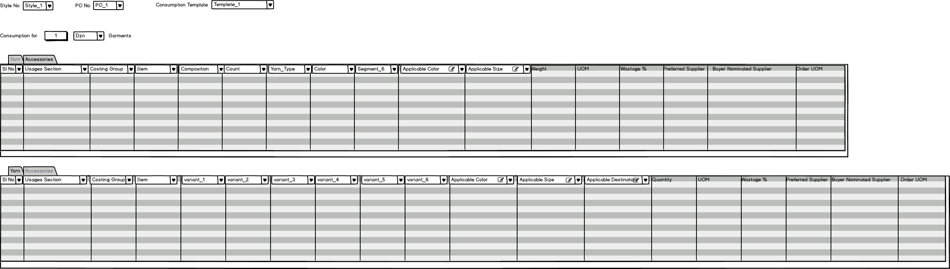

Fig: Material Consumption

* + 1. **Bill Of Material (BOM)**

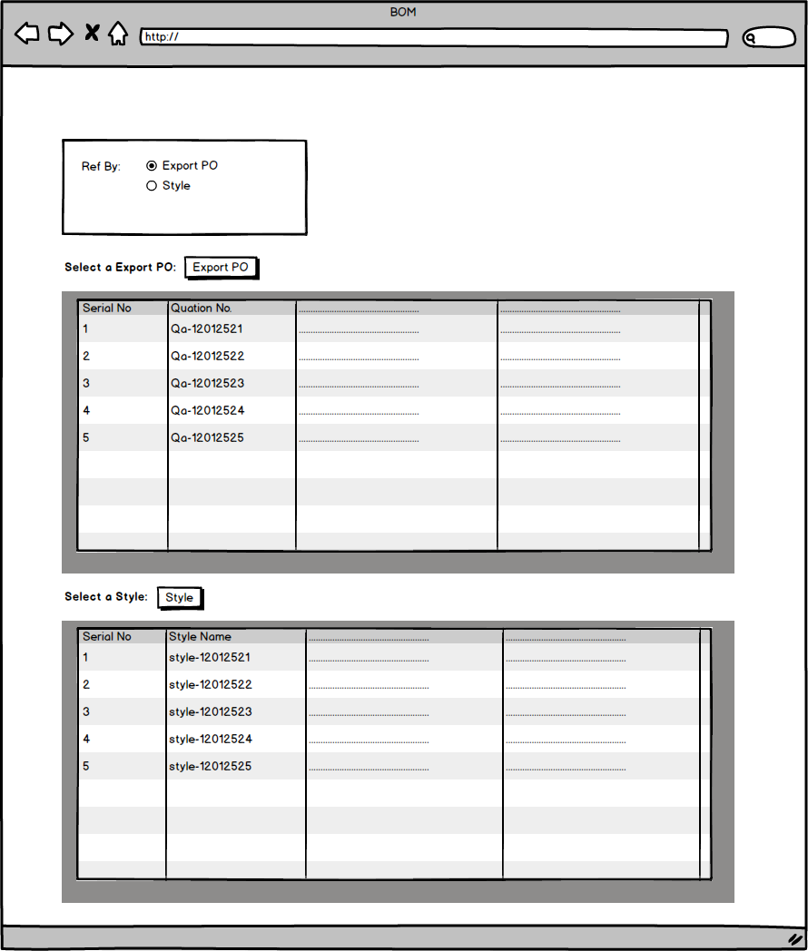

Fig: Bill Of Material (BOM)

# Procurement

## Overview

Procurement is the act of buying goods, services or works from an external source. It is favorable that the goods, services or works are appropriate and that they are procured at the best possible cost to meet the needs of the acquirer in terms of quality and quantity, time, and location. Generic process flow of procurement is:

## Procurement Process Flow

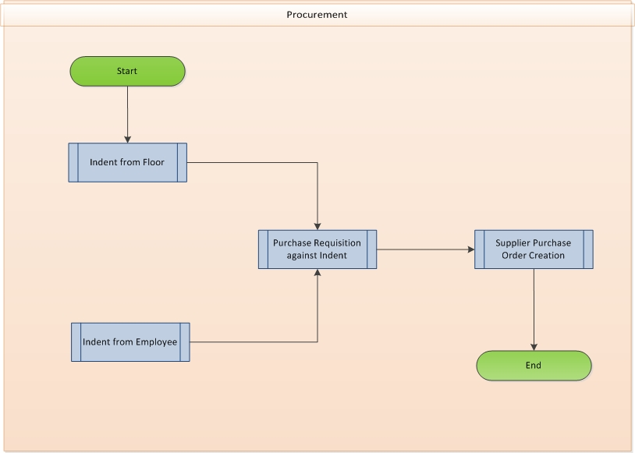

Fig: Procurement process flow diagram

## Procurement use case diagram and description

### Purchase Requisition

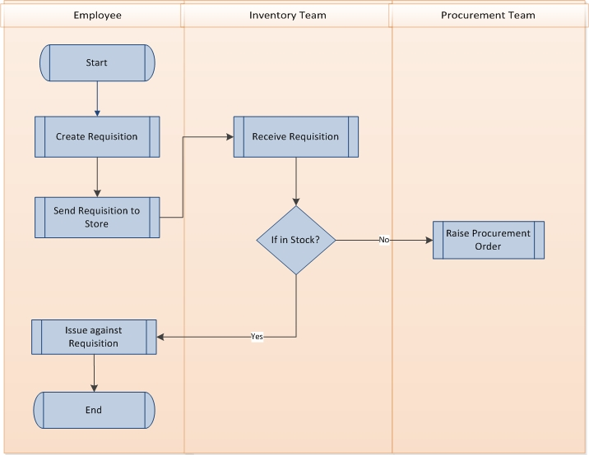

Fig: Purchase requisition

|  |  |  |
| --- | --- | --- |
| Use Case ID: UCD/Pro/001 | | |
| Use Case Name**: Purchase Requisition** | | |
| Created By: **GenWeb2 Ltd.** | | Date Created: **10 September 2015** |
| Actors: | * Employee, Inventory manager, Procurement Manager | |
| Trigger: | * When any general item is required * When any raw materials for production (Not from BOM or extended) is required | |
| Business Rule | * It generate a requisition for some items where those need to be sourced | |
| Description: | 1. Store will receive purchase requisition from either internal floor or from other department. 2. Store will check availability of the item in the store. 3. If item is not available then will raise a purchase requisition to procurement team. | |
| Frequency of Use | * High | |
| Preconditions | * Indent (Optional) | |
| Post conditions | * Inventory Issue (If exists) * Supplier Purchase Order | |
| Assumption |  | |
| Goal | * To keep track for any item requirement * Making sure to raise purchase order when requires and with chain. | |
| Normal Flow | * Anybody from any department may raise purchase requisition to store for the require items. Inventory try to issue that item is it is available for issue or else supplier purchase order being raised against this requisition | |
| Alternate Flow | * N/A | |
| Exception | * N/A | |
| Cross Reference | * N/A | |

### Supplier Purchase Order:

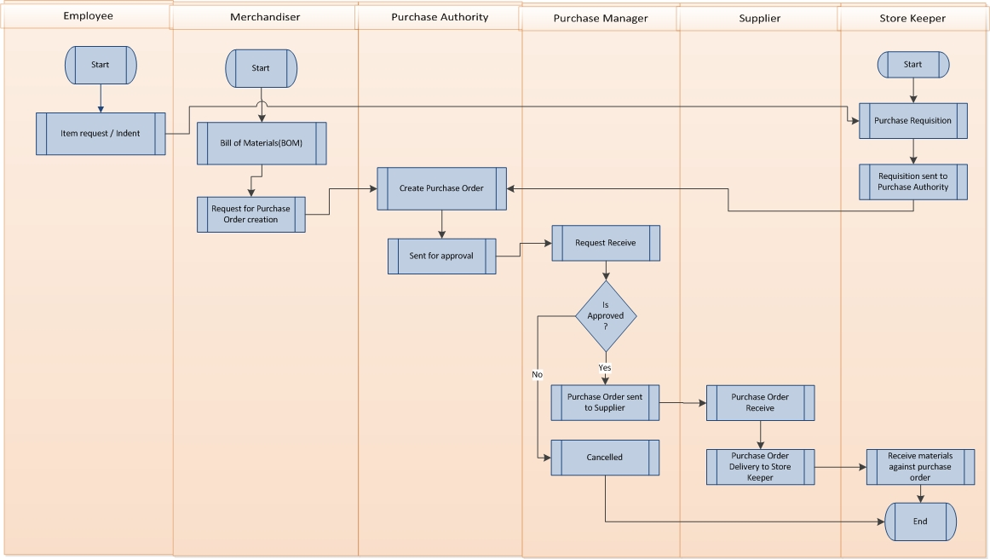

Fig: Supplier purchase order

|  |  |  |
| --- | --- | --- |
| Use Case ID: UCD/Pro/002 | | |
| Use Case Name**: Supplier Purchase Order** | | |
| Created By: **GenWeb2 Ltd.** | | Date Created: **10 September 2015** |
| Actors: | * Procurement Manager, Supplier | |
| Trigger: | * When any items require to purchase doesn’t matter whether BOM items or general | |
| Business Rule | * Procurement team gives order to supplier for any goods | |
| Description: | 1. Purchase order can be raised against any requisition from employee 2. Purchase order can be raised against the BOM item purchase request 3. Purchase order can be raised against regular inventory purchase requisition 4. If approval authority approve then the purchase order moves to supplier 5. Supplier deliver the goods to inventory 6. Inventory receives the goods | |
| Frequency of Use | * High | |
| Preconditions | * Purchase Requisition | |
| Post conditions | * Materials Delivery by supplier and receive by store (For No LC Item) | |
| Assumption |  | |
| Goal | * To keep track for any item requirement * Making sure to raise purchase order when requires and with chain. | |
| Normal Flow | * Anybody from any department may raise purchase requisition to store for the require items. Inventory try to issue that item is it is available for issue or else supplier purchase order being raised against this requisition | |
| Alternate Flow | * N/A | |
| Exception | * N/A | |
| Cross Reference | * N/A | |

## Procurement User interface mock-up

### Supplier Purchase Requisition

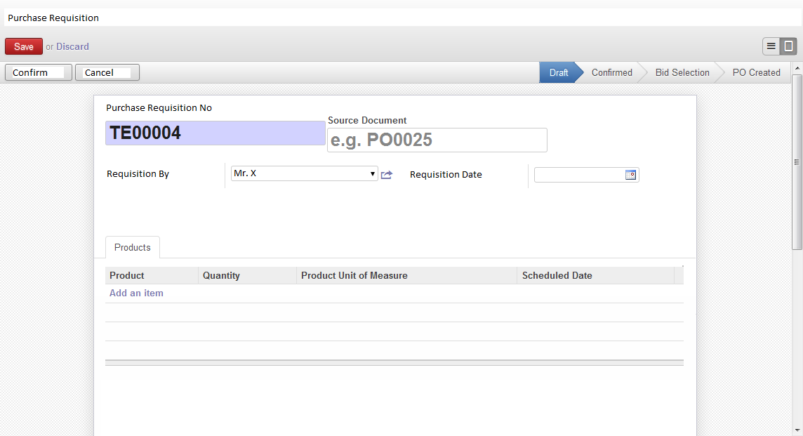

### Supplier purchase order

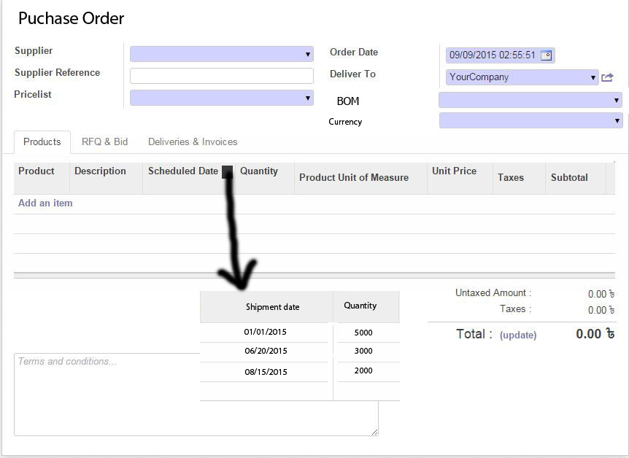

Fig: Supplier Purchase Order

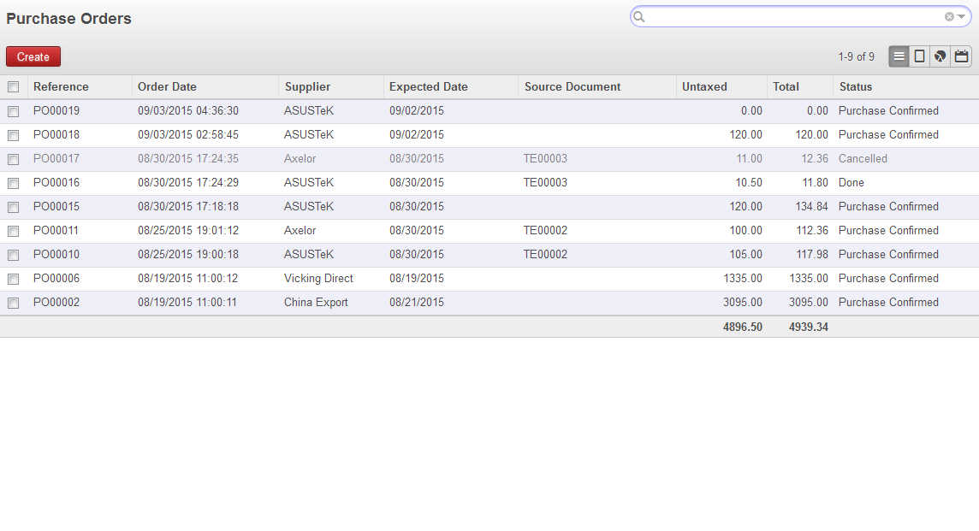

Fig: Supplier purchase order List

# Inventory

## Overview

Inventory management is a science primarily about specifying the shape and percentage of stocked goods. It is required at different locations within a facility or within many locations of a supply network to precede the regular and planned course of production and stock of materials.

## Inventory process flow

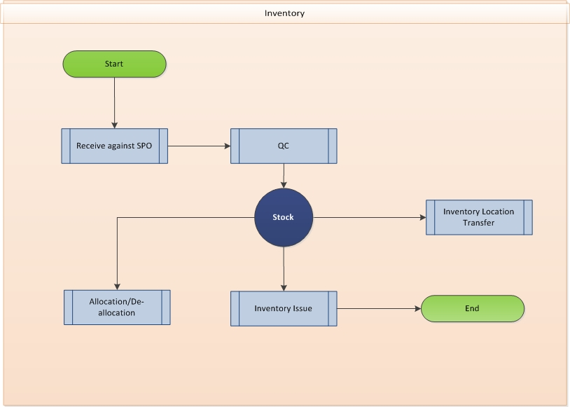

Fig: Inventory process flow

## Inventory Use case diagram and description

### Inventory Receive

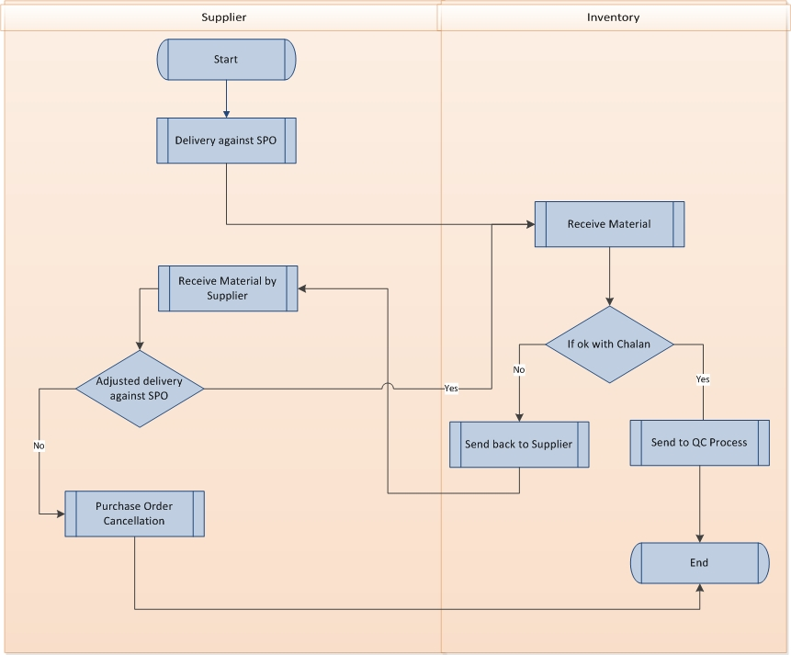

Fig: Inventory Receive

|  |  |  |
| --- | --- | --- |
| Use Case ID: UCD/Inv/001 | | |
| Use Case Name**: Inventory Receive** | | |
| Created By: **GenWeb2 Ltd.** | | Date Created: **10 September 2015** |
| Actors: | * Inventory Authority, Supplier | |
| Trigger: | * When Supplier deliver any goods to inventory | |
| Business Rule | * Inventory Authority receive goods against purchase order | |
| Description: | 1. Inventory can receive goods against Supplier Purchase Order 2. Inventory can receive goods against commercial Invoice 3. Cash purchase item also can be received in inventory 4. Inventory acknowledge the receive items against any  Sales Purchase Order (SPO)/Commercial Invoice (CI). 5. Only QC passed quantity will moved to stock 6. Failed quantity will move to supplier and then supplier may send replace the QC failed quantity. 7. Inventory again receive that QC failed replaced item sent by supplier | |
| Frequency of Use | * High | |
| Preconditions | * Supplier Purchase order * Commercial Invoice * Cash purchase | |
| Post conditions | * Inventory QC | |
| Assumption |  | |
| Goal | * To keep track for any inventory receive * To make sure to keep transparency in every steps of inventory transactions | |
| Normal Flow | * Authorized inventory person receive against SPO/CI | |
| Alternate Flow | * N/A | |
| Exception | * N/A | |
| Cross Reference | * N/A | |

### Inventory QC

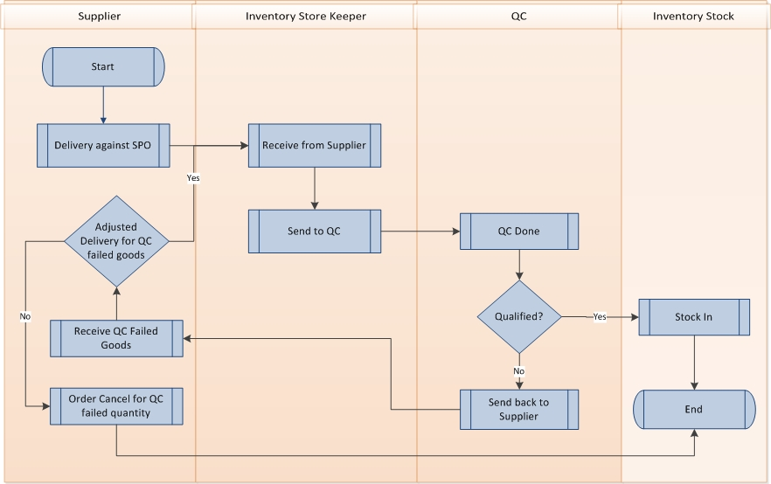

Fig: Inventory QA

|  |  |  |
| --- | --- | --- |
| Use Case ID: UCD/Inv/002 | | |
| Use Case Name**: Inventory QC** | | |
| Created By: **GenWeb2 Ltd.** | | Date Created: **10 September 2015** |
| Actors: | * Inventory Authority, Quality Inspector | |
| Trigger: | * When any inventory receive happen | |
| Business Rule | * After inventory receive Inventory QC take place to ensure solid stock in the Inventory | |
| Description: | 1. Quality Inspector inspects the received materials and passed only the quality products. So only accepted products move to stock 2. Authority will pay the supplier only the QC passed quantity value 3. QC failed quantity goes back to respective supplier 4. If supplier again delivers the replacement of the QC failed items those will be in inventory QC process again. | |
| Frequency of Use | * High | |
| Preconditions | * Inventory Receive | |
| Post conditions | * Inventory Transfer/Inventory Allocation and reallocation/Inventory Issue | |
| Assumption |  | |
| Goal | * To ensure only quality products in Stock * Not to pay for the disqualified products * To avoid any further raw material shortage during production period | |
| Normal Flow | * After inventory receive Quality Inspector do the QC and only passed quality moves to stock | |
| Alternate Flow | * N/A | |
| Exception | * N/A | |
| Cross Reference | * N/A | |

### Inventory Transfer

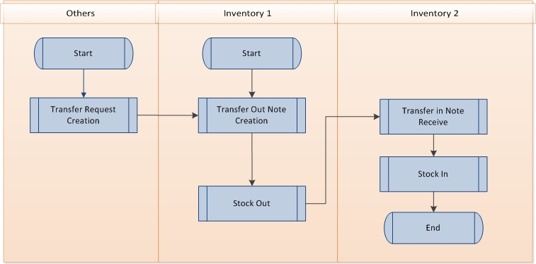

Fig: Inventory transfer

|  |  |  |
| --- | --- | --- |
| Use Case ID: UCD/Inv/003 | | |
| Use Case Name**: Inventory Transfer** | | |
| Created By: **GenWeb2 Ltd.** | | Date Created: **10 September 2015** |
| Actors: | * Inventory Authority | |
| Trigger: | * When item transfer happen for any inventory location to another | |
| Business Rule | * Transferring item from one inventory stock to another inventory stock | |
| Description: | 1. Against any transfer request any storekeeper create transfer out note. 2. Against that transfer out note stock moves from that respective inventory 3. Receivable inventory receive the goods against the transfer note and update the stock. | |
| Frequency of Use | * Medium | |
| Preconditions | * Stock availability | |
| Post conditions |  | |
| Assumption |  | |
| Goal | * To ensure proper inventory stock availability management | |
| Normal Flow | * Transfer happen against any transfer request * Transfer out inventory reduce the transfer quantity from the stock and the transfer receive inventory acknowledge and increase the stock with the receive quantity. | |
| Alternate Flow | * N/A | |
| Exception | * N/A | |
| Cross Reference | * N/A | |

### Inventory Allocation and De-allocation

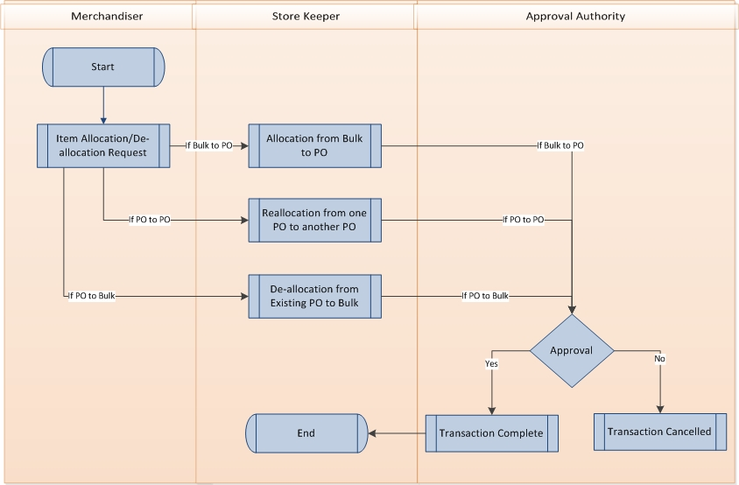

Fig: Inventory allocation de-allocation

|  |  |  |
| --- | --- | --- |
| Use Case ID: UCD/Inv/004 | | |
| Use Case Name**: Inventory Allocation, De-allocation and reallocation process** | | |
| Created By: **GenWeb2 Ltd.** | | Date Created: **10 September 2015** |
| Actors: | * Inventory Authority | |
| Trigger: | * When any inventory item need to allocate with certain PO or keep free to use anywhere | |
| Business Rule | * Tagging any item to certain Buyer order so it can be used dedicatedly | |
| Description: | 1. Allocation request raise from merchandising level. 2. There could be 3 types of allocation:    1. Allocate bulk/free item stock to any Export PO    2. Allocate assigned PO item stock to other PO    3. De-allocate any item stock from any PO to Bulk/free 3. Approval needed for every request 4. If get approved then stock association will move from one stock to another. | |
| Frequency of Use | * Medium | |
| Preconditions | * Stock availability | |
| Post conditions | * Issue against PO | |
| Assumption |  | |
| Goal | * To ensure proper stock availability as per requirements | |
| Normal Flow | * Allocate bulk/free item stock to any Export PO so that item would be fixed only to issue against that Export PO * Allocate assigned PO item stock to other PO so that the stock would be shifted to other PO for issue. * De-allocate any item stock from any PO to Bulk/free so stock may stay free to further use. | |
| Alternate Flow | * N/A | |
| Exception | * N/A | |
| Cross Reference | * N/A | |

### Inventory issue

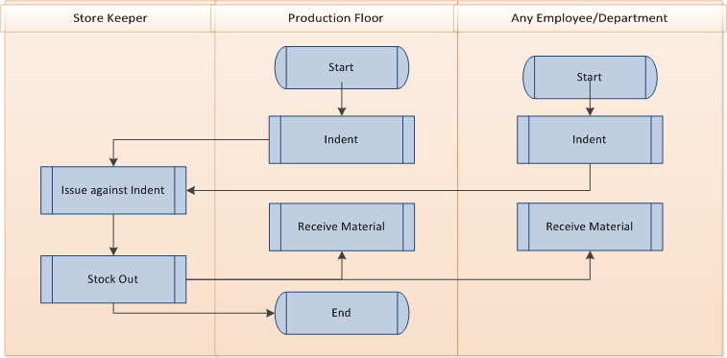

Fig: Inventory issue

|  |  |  |
| --- | --- | --- |
| Use Case ID: UCD/Inv/005 | | |
| Use Case Name**: Inventory Issue** | | |
| Created By: **GenWeb2 Ltd.** | | Date Created: **10 September 2015** |
| Actors: | * Inventory Authority | |
| Trigger: | * When any inventory item needs to issue to production floor or any other purpose | |
| Business Rule | * Issuing item stock to production floor or any purpose | |
| Description: | 1. There are 3 types of issue transactions:    1. Issuing Item stock to production floor against indent    2. Issuing item stock to maintenance purpose against indent    3. Issuing item stock to user/employee use against indent 2. Every successful transaction will reduce stock | |
| Frequency of Use | * High | |
| Preconditions | * Stock availability & requirement | |
| Post conditions |  | |
| Assumption |  | |
| Goal | * To ensure decrease stock and proper issue log | |
| Normal Flow | * Issue against allocated PO * Issue independently | |
| Alternate Flow | * N/A | |
| Exception | * N/A | |
| Cross Reference | * N/A | |

## Inventory user interface mock-up

### Inventory receive

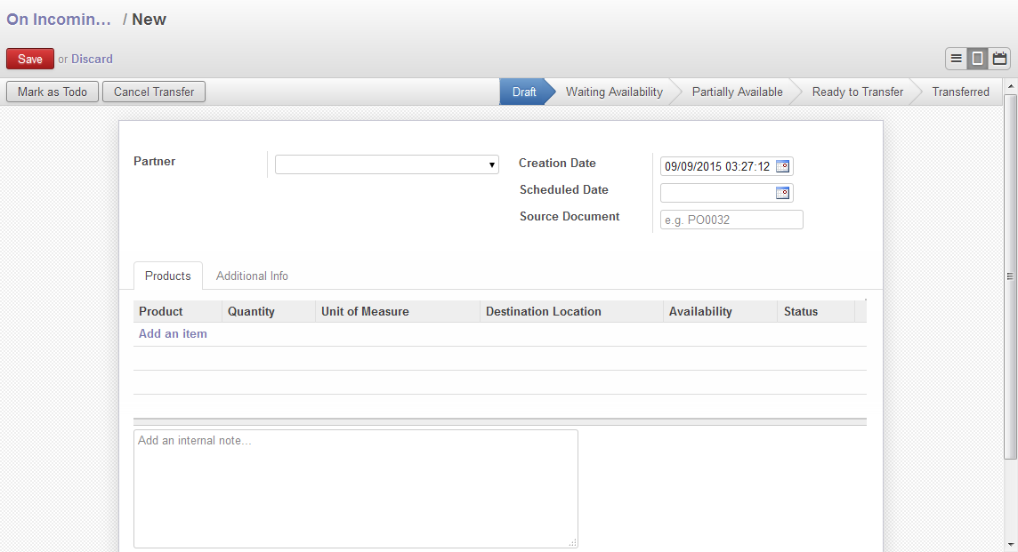

Fig: Inventory Receive

### Inventory QC

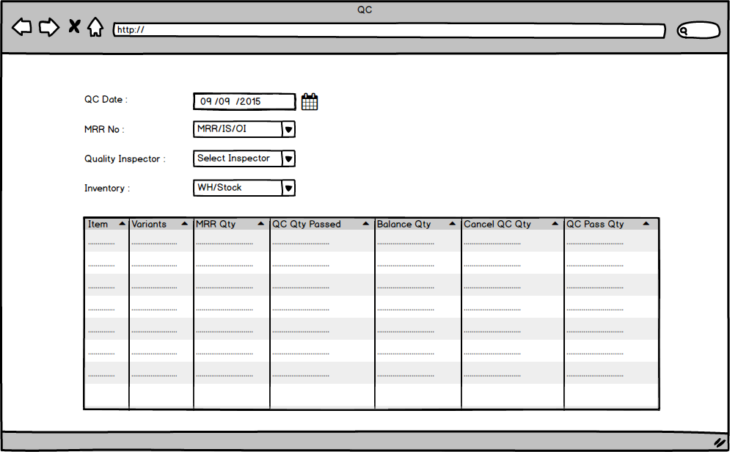

Fig: Inventory QC

### Inventory transfer

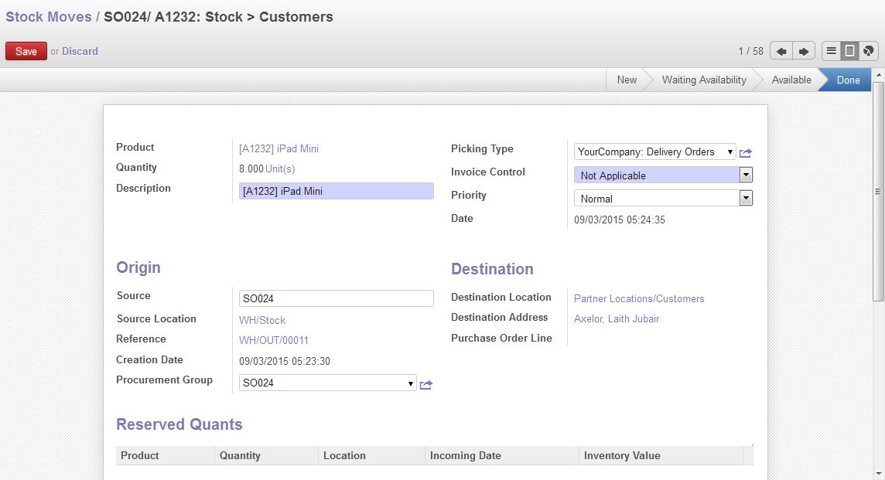

Fig: Inventory Transfer

### Inventory Allocation & De-allocation

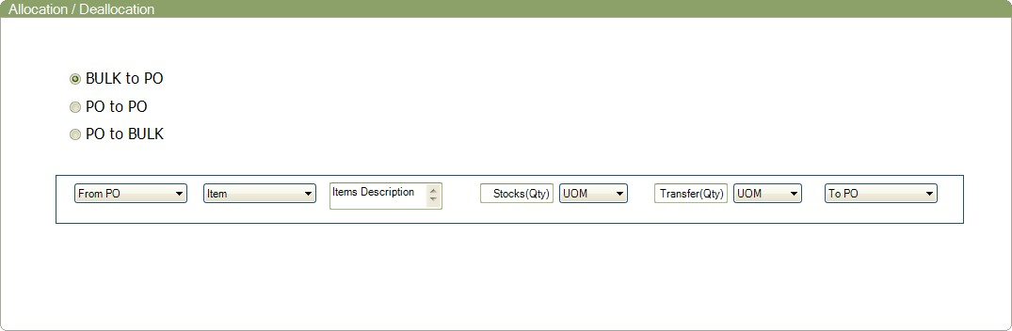

Fig: Inventory allocation de-allocation

### Inventory issue

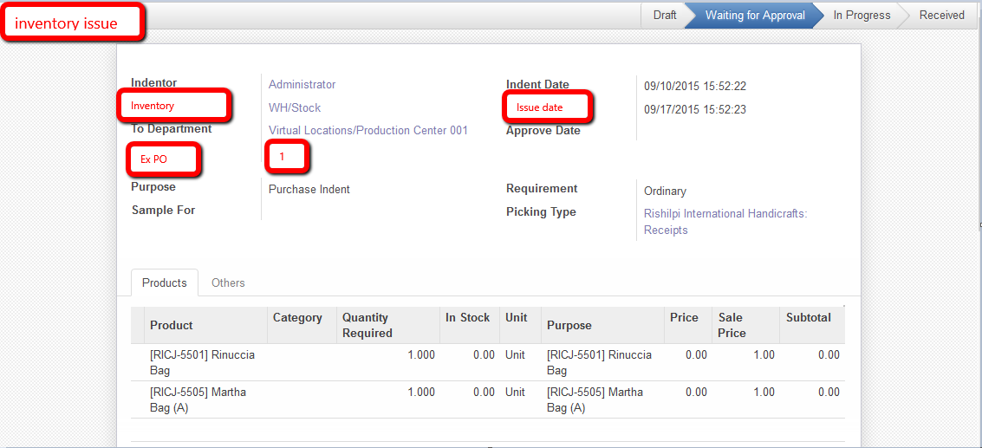

Fig: Inventory issue